Ayush Goyal
190905522 CSE D 62

Distributed Systems Week 4: Lab 4: Socket Programming using Python

Lab Excercise:

1. Write a UDP time server to display the current time and day.

Time Server: “l4q1ser.py”:

import socket
import time

sock = socket.socket(socket.AF_INET, socket.SOCK_DGRAM)
udp_host = socket.gethostname()
udp_port = 12345

sock.bind((udp_host, udp_port))

while True:
print("Waiting for client")
data,addr = sock.recvfrom(1024)
print("Received messages: ", data.decode(),"from ", addr)

# Sending a reply to client
currentTime = time.ctime(time.time()) + "\r\n"
bytesToSend = str.encode(currentTime)
sock.sendto(bytesToSend, addr)

Client: “l4q1cli.py”:

import socket

sock = socket.socket(socket.AF_INET, socket.SOCK_DGRAM)

udp_host = socket.gethostname()
udp_port = 12345

msg = "Hello UDP Server!"
print("UDP target IP: ", udp_host)
print("UDP target Port: ", udp_port)

sock.sendto(msg.encode(), (udp_host, udp_port))
msgFromServer = sock.recvfrom(1024)
msg = "Message from Server {}".format(msgFromServer[0])
print(msg)

Server Side Terminal Output:

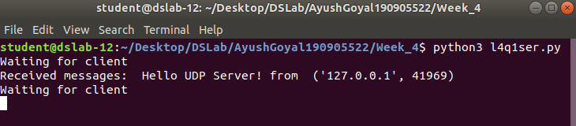

Client Side Terminal Output:

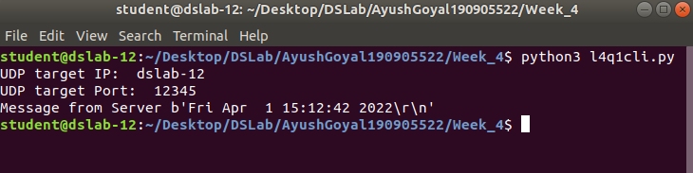

2. Write a UDP simple chat program for message send and receive.

Server: “l4q2ser.py”:

import socket

serversocket = socket.socket(socket.AF_INET,socket.SOCK_DGRAM)

udp_host = socket.gethostname()
udp_port = 12345

serversocket.bind((udp_host,udp_port))
print('Do Ctrl+c to exit the program!!')
while True:
print("####### Server is listening ###########")
data,addr = serversocket.recvfrom(1024)
print('2. Server Recieved: ', data.decode())
message = input('Type some text to send => ')
serversocket.sendto(message.encode(),addr)
print('1. Server Sent:', message)

Client: “l4q2cli.py”:

import socket

s = socket.socket(socket.AF_INET,socket.SOCK_DGRAM)

udp_host = socket.gethostname()
udp_port = 12345

print('Do Ctrl+c to exit the program!!')
while True:
message = input('Type some text to send => ')
s.sendto(message.encode(),(udp_host,udp_port))
print('1. Client Sent: ',message)
data = s.recv(1024)
print('2. Client Recieved: ', data.decode())

Server Side Terminal Output:

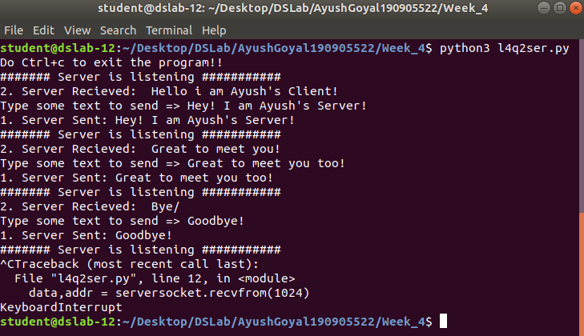

Client Side Terminal Output:

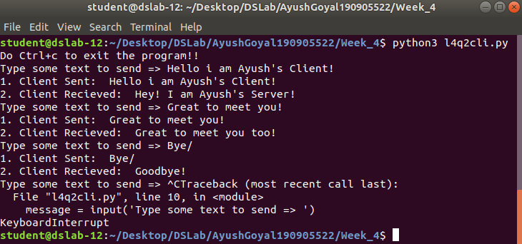
3. Write a TCP/UDP peer to peer chat system between two different machines.

(Me and my friend, Dipesh Singh(190905520) have used peer to peer chat system using my pc as server and his pc as client and have shown output for inter device peer to peer chat system.)

1st PC: Ayush Goyal (190905522) : 172.16.58.44/24
2nd PC: Dipesh Singh (190905520) : 172.16.58.153/24

We can find my PC’s IP Address by executing ip addr:

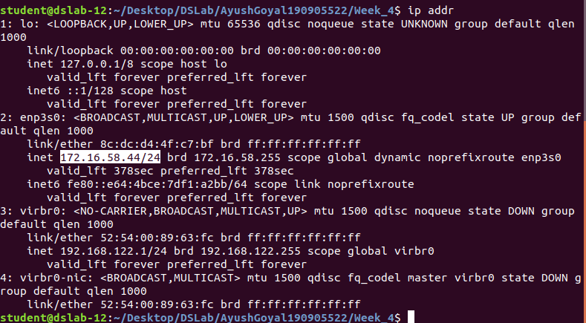
Similarly we can find Dipesh’s PC’s IP Address too:

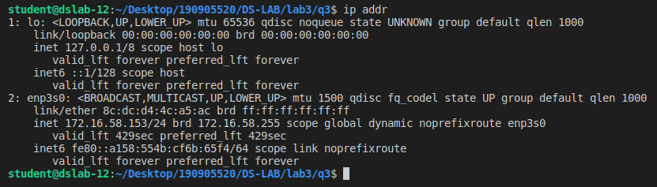

Server: “l4q3ser.py”:

import socket

host = '172.16.58.44'
port = 3000
s = socket.socket()
s.bind((host, port))
s.listen(5)
conn, addr = s.accept()
print(conn, addr)
while True:
data = conn.recv(1024)
if str(data).find('exit') != -1:
break
print("The sender sent : ", str(data))
msg = input("Enter a message to send : ")
if msg.find('exit') != -1:
break
conn.sendall(str.encode(msg, encoding='utf-8'))
conn.close()

Client: “l4q3cli.py”:

import socket
host = '172.16.58.44'
port = 3000
s = socket.socket()
s.connect((host, port))
while True:
msg = input("Enter a message to send : ")
if msg.find('exit') != -1:
break
s.sendall(str.encode(msg, encoding='utf-8'))
data = s.recv(1024)
if str(data).find('exit') != -1:
break
print("The sender sent : ", str(data))
s.close()

When my PC is the server and Dipesh’s PC is the client:

Server Side Terminal Output(My PC) :

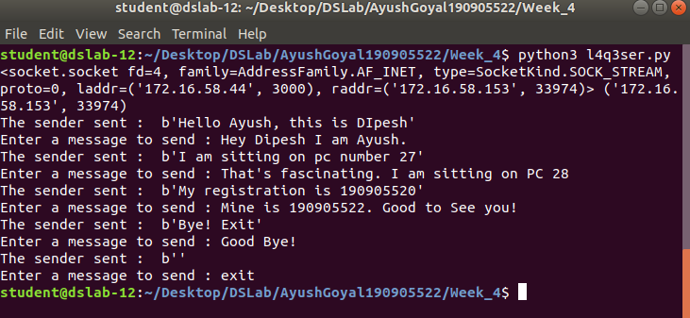

Client Side Terminal Output (Dipesh’s PC) :

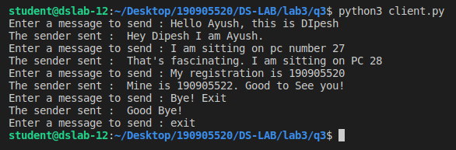

When we switch the PC and now my PC is the client and Dipesh’s PC is the server:

Server Side Terminal Output(Dipesh’s PC) :

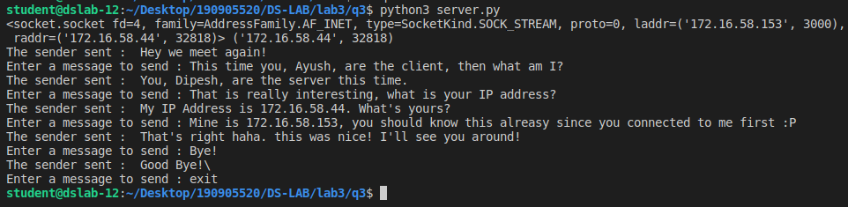

Client Side Terminal Output (My PC) :

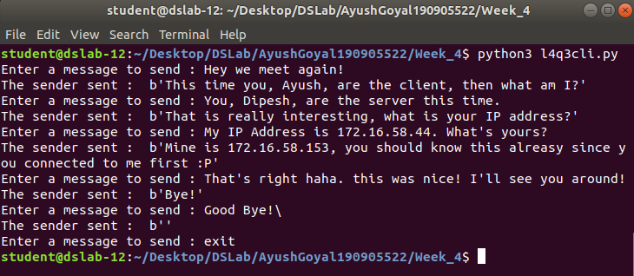

4. Try to debug the error in the code and execute it.

Wrong Codes:

Client:

import socket

serverIP = 'localhost'
serverPort = 16000

clientSock = socket.socket(socket.AF_INET, socket.SOCK_STREAM)
clientSock.connect((serverIP, serverPort))

message = raw_input("Input integers with space in between: ")
message2 = raw_input("Enter the length of the set: ")

clientSock.send(message)
clientSock.send(message2)

data = clientSock.recv(1024)
temp = [float(x) for x in data.split(' ')]

print("The total of all numbers is: "+str(temp[0]))
print("The lowest number is: "+str(temp[1]))
print("The highest number is: "+str(temp[2]))
print("The mean is: "+str(temp[3]))

clientSock.close()

Server:

import socket

serverIP = 'localhost'
serverPort = 16000
serverSock = socket.socket(socket.AF_INET, socket.SOCK_STREAM)
serverSock.bind((serverIP, serverPort))
serverSock.listen(1)
print("TCP Serverhas started and is ready to receive!")

while 1:
connection, addr = serverSock.accept()
data = connection.recv(1024)
if not data: break
temp = [float(x) for x in data.split(' ')]
print "Received data : ", temp
length = len(temp)
maximum = max(temp)
minimum = min(temp)
total = sum(temp)
mean = total/length
msg = str(total) + " " + str(minimum) + ' ' + str(maximum) + " " + str(mean)
connection.send(str(msg))

Expected Output:
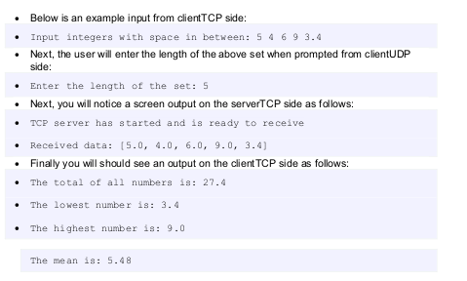

Changes:

In Server:

Move this out of the while loop:

connection, addr = serverSock.accept()

Changed from 1 to True:

while True:

Add decode method:

temp = [float(x) for x in data.decode('utf-8').split(' ')]

Put paranthesis:

print("Received data : ", temp)

Add str.encode()

connection.send(str.encode(msg, 'utf-8'))

In Client:

Change to input and remove message2:

message = input("Input integers with space in between: ")

Add encode:

clientSock.send(str.encode(message, 'utf-8'))

Add decode:

temp = [float(x) for x in data.decode('utf-8').split(' ')]

Corrected Codes:

Client:

import socket

serverIP = 'localhost'
serverPort = 16000

clientSock = socket.socket(socket.AF_INET, socket.SOCK_STREAM)

clientSock.connect((serverIP, serverPort))

message = input("Input integers with space in between: ") # change to input and remove message2
clientSock.send(str.encode(message, 'utf-8')) #add encode

data = clientSock.recv(1024)

temp = [float(x) for x in data.decode('utf-8').split(' ')] #add decode

print("The total of all numbers is: "+str(temp[0]))
print("The lowest number is: "+str(temp[1]))
print("The highest number is: "+str(temp[2]))
print("The mean is: "+str(temp[3]))

clientSock.close()

Server:

import socket

serverIP = 'localhost'
serverPort = 16000

serverSock = socket.socket(socket.AF_INET, socket.SOCK_STREAM)
serverSock.bind((serverIP, serverPort))
serverSock.listen(1)

print("TCP Server has started and is ready to receive!")
connection, addr = serverSock.accept() # move this out of the while loop

while True: # changed from 1 to True
data = connection.recv(1024)
if not data: break
temp = [float(x) for x in data.decode('utf-8').split(' ')] # add decode method
print("Received data : ", temp) # put parentheses
length = len(temp)
maximum = max(temp)
minimum = min(temp)
total = sum(temp)
mean = total/length
msg = str(total) + " " + str(minimum) + ' ' + str(maximum) + " " + str(mean)
connection.send(str.encode(msg, 'utf-8')) # add str.encode

Correct Server Output:

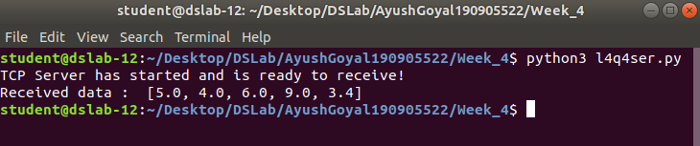
Correct Client Output:

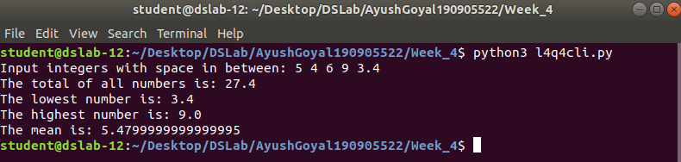

THE END

